We've created the [**Learn Management Online Facebook Group**](https://www.facebook.com/groups/learnmanagementonline/) for you!

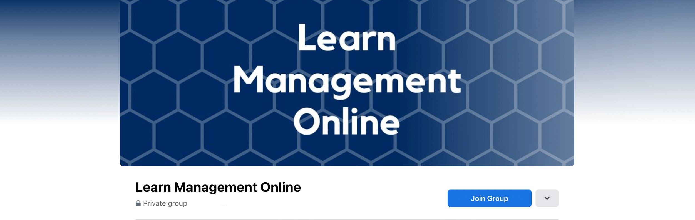

**YOU MUST ANSWER THE REQUIRED MEMBERSHIP QUESTIONS TO JOIN**

When joining the group, you'll be asked ***How did you find out about this group?***

Make sure you say **I am from learnmanagementonline.com** when answering this question, so I know you have enrolled in one of my courses.

Along with being able to ask questions and get support in the course, you can also find help in this group, which is here for you to:

* **Ask questions**
* **Share your own knowledge and advice**
* **Support your fellow students**
* **Stay up to date with course information and updates**

This Group is for Educational Purposes and you will need a Facebook account to access the group.

[**CLICK HERE TO JOIN THIS GROUP**](https://www.facebook.com/groups/learnmanagementonline)

or go to www.facebook.com/groups/learnmanagementonline to join our official group

*If you don't have Facebook, then don't worry.*

You will get support and updates right in this course as well. Just make sure your email notifications are turned on so you get any updates!

See you in the group!

Michael James